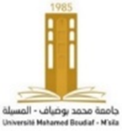

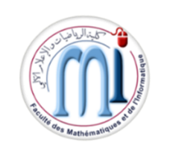

[**NCMA'2024 : Second National Conference on Mathematics and Applications**](https://ncma2024.sciencesconf.org/)

**27-28 Nov 2024 M'sila (Algeria)**

*Please fill out this form and send it together with your payment receipt via email to:*

[**nasser.ghedbane@univ-msila.dz**](mailto:ncamsa24@univ-batna2.dz) *. Deadline:* ***November 20, 2024****.*

|  |  |
| --- | --- |
| **First Name:** | **…………………………………………………………………** |
| **Last Name:** | **……………………………………………………………………** |
| **E-mail:** | **………………………** |
| **Phone:** | **……………………………………………………..** |
| **In collaboration with:**  **First name: …………………………**  **Last name: …………………………….**  **Affiliation: ………………………………..**  **E-mail: ………………………………………**   |  |  | | --- | --- | | **Category** | **Fees** | | **Faculty members and researchers** | **☐ 6000 DA** | | **PhD Students** | **☐ 3000 DA** | | |

|  |  |
| --- | --- |
| **PAYMENT METHOD**  **Please, make a bank transfert (from a bank or from a ccp account) to the account ccp *université de M’sila : 007999990000321528 clé 93*** |  |

Note: A copy of the remittance receipt should be sent together with this registration form.

|  |  |
| --- | --- |
| **Date:** | **Signature:** |

**Author registration type includes:**

* Access to all conference sessions
* Conference materials and document holder
* Coffee breaks and lunches
* Certificate of attendance